
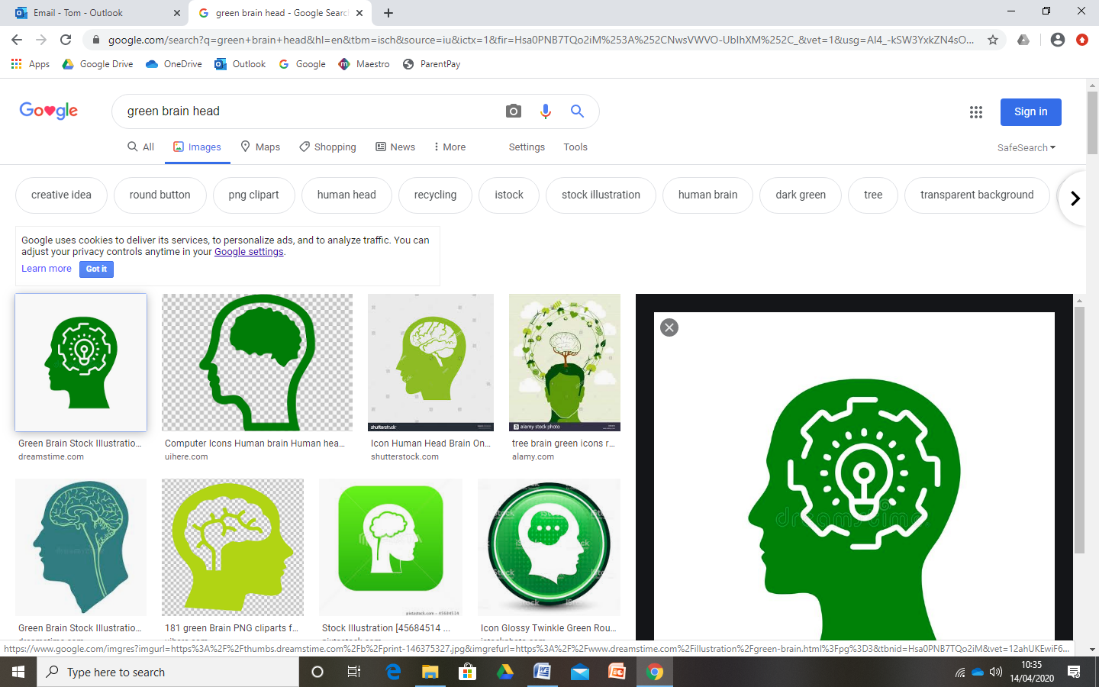

Heart
The key values to let our light shine are:
- Self Control and The Rule of Law

Head
This is the knowledge we will gain this half term. For example:
- Who helps us in our community?
- How can I be a person who helps others?
- How have different occupations changed
over time?

Hand
These are the skills we will learn this half term. For example:
- Listening to others as they talk/explain
- Questioning – asking questions
to develop our own
understanding

Ladybirds EYFS
Journey of Discovery Spring 1

People Who Help Us

Literacy
- Reading non-fiction books about People Who Help Us
- Using our phonics to label images, write captions to pictures and create posters
- Phonics – learn digraphs using
our school phonics resource.

Maths
- Count beyond 10 and subitise to 6
- Solving real life number problems
- Use positional, directional and
sequential language
- Repeating patterns – spot the mistake!

Where 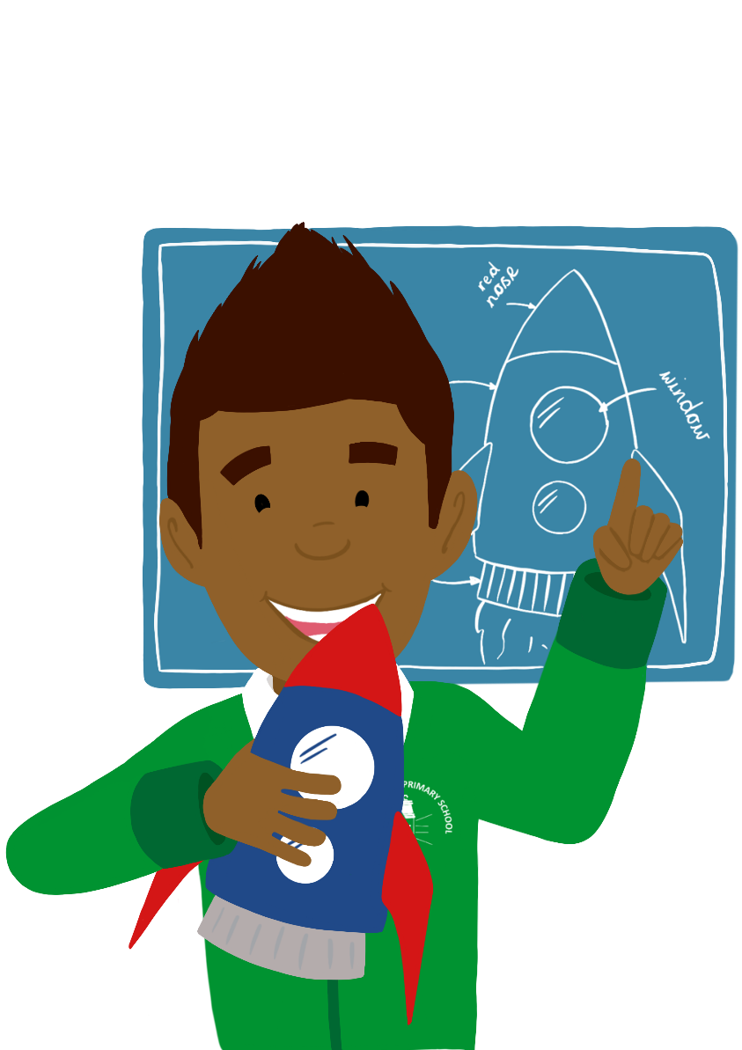 will we be visiting this half term?
National S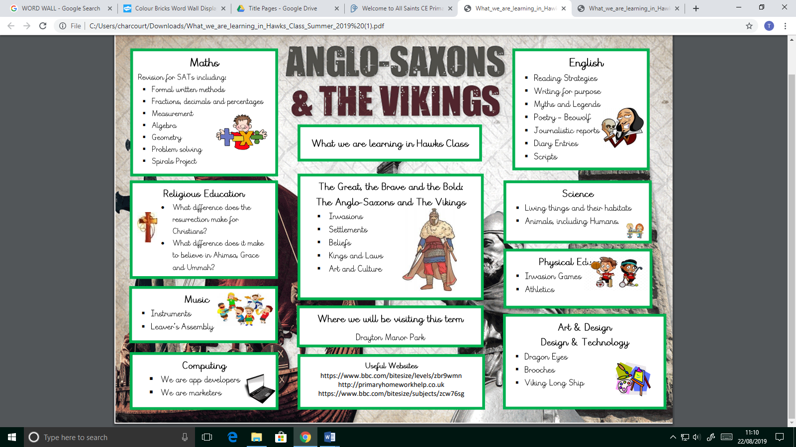pace Centre
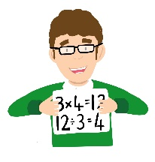
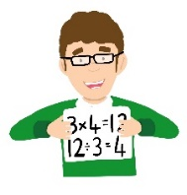
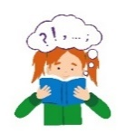

Religious Education
- Why is the word God so important to
Christians?

Understanding the World
- Learning about different occupations and how they have changed over time – past/present
- Developing an understanding of the differences between people
- Exploring the properties of different
objects
- Exploring different forces –
gravity/friction

Personal, Social and Emotional Development
- Developing our sense of self – how can we contribute to our community and help others?
- Collaborate with others to
achieve a goal
- Develop perseverance through
completing Emergency
Service challenges

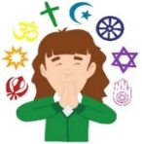

Communication and Language
- Learning new vocabulary about the Emergency
Services and other People Who Help Us
- Asking questions to develop our own
understanding

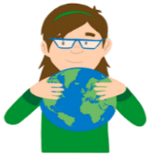
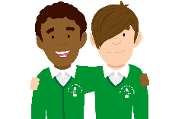

Expressive Arts and Design
- People Who Help Us Role Play area and small world play
- Creating collages
- Listening to different songs/pieces of music
and expressing our feelings
- Singing nursery rhymes and using
Instruments to make music

Spark day
- Visits from People Who Help Us in our community – local PCSOs, Fire Fighters, Crossing Patrol, Vet etc.

Physical Development
- Gymnastics in PE
- Getting dressed and
undressed independently.
- Moving with rhythm and
to music
- Practicing handwriting in
phonics
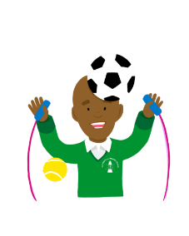
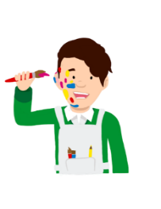
Book List
What The Ladybird Heard Burglar Bill
The Jolly Postman Happy Families Stories
Emergency Services non-fiction texts.

