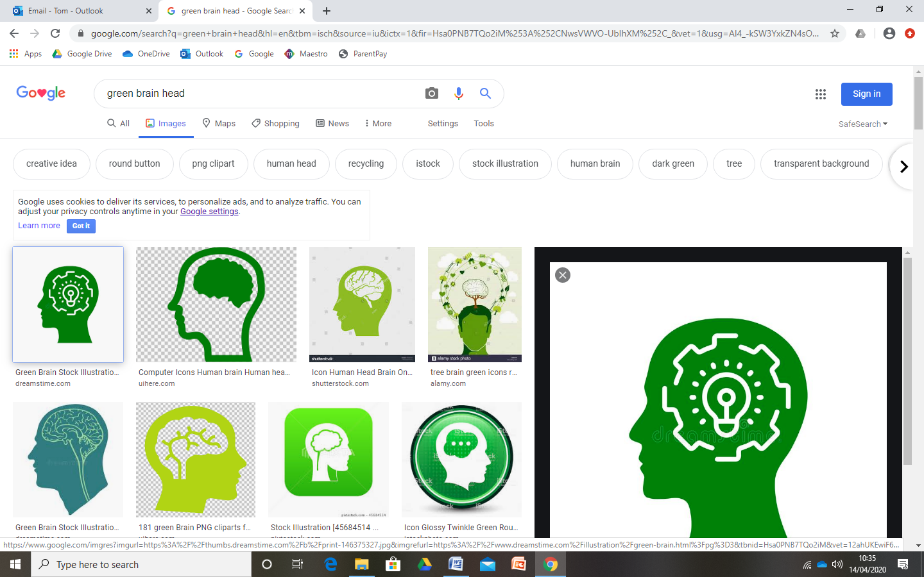


Heart
The key values to let our light shine are:
- Generosity and Appreciation

Head
This is the knowledge we will gain this half term. For example:
- How has travelling changed over time?
- How do we travel around the world?
- What does life look like in other
countries?

Hand
These are the skills we will learn this half term. For example:
- Collage techniques
- Using instruments
- Creating a pictogram to show
data

Ladybirds and Bumblebees EYFS
Journey of Discovery Autumn 2

Around the World

Literacy
- Reading and writing CVC words
- Beginning to write labels and captions
- Reading non-fiction books about our world
- Identifying learned letter/sound
correspondences
Maths
- Matching numerals to amounts to 10
- Undertaking a vehicle survey
- Creating patterns
- Combining shapes to make
pictures
Where 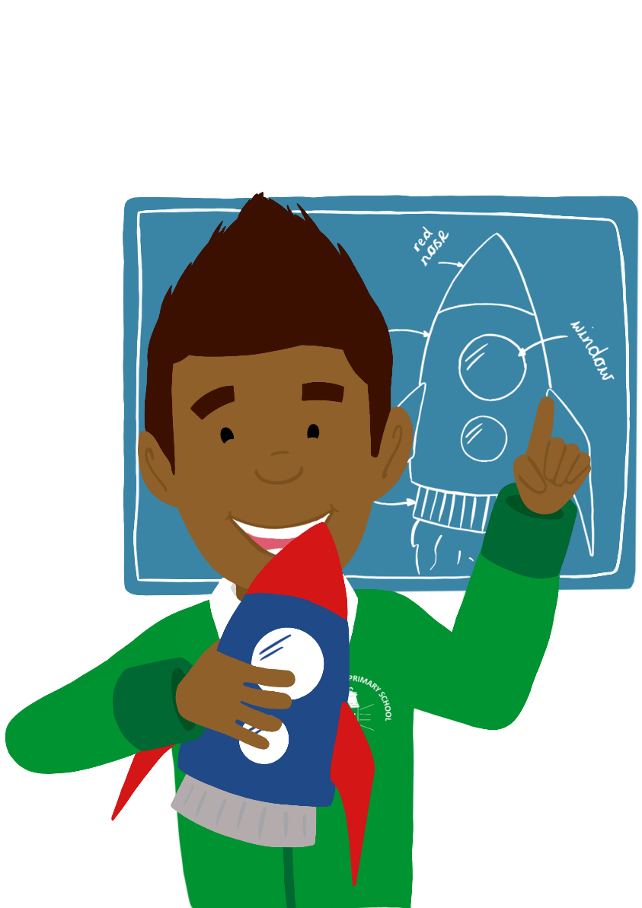 will we be visiting this half term?
National S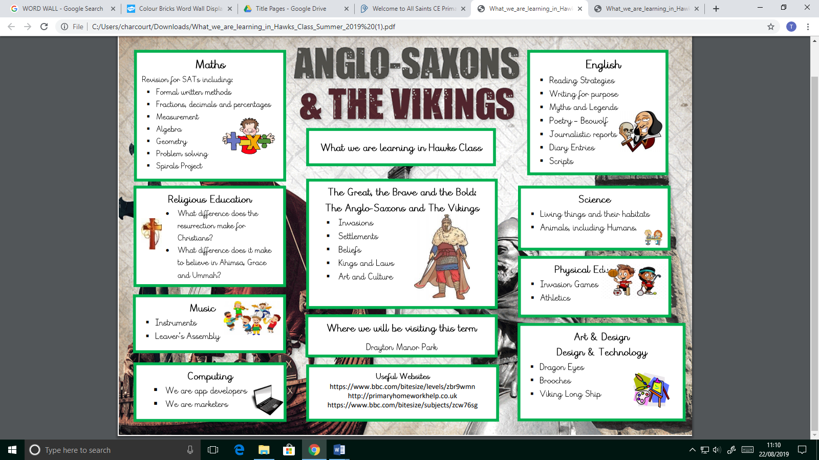pace Centre
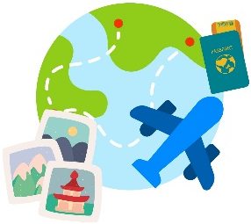
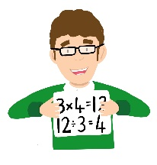
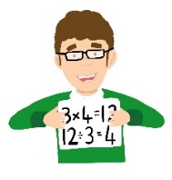
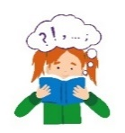

Religious Education
- Celebrating All Saints Day
- Diwali – Why do Hindus celebrate Diwali?
- Why do Christians perform Nativity
plays at Christmas.

Understanding the World
- Planting spring bulbs in the garden
- Learning about the country we live in and other countries around the world.
- eSafety lessons
- Bonfire Night
- Looking at maps and exploring different environments.
- Learning about Coalville’s mining
History, and how Coalville looked
in the past.

Personal, Social and Emotional Development
- Sharing and taking turns
- Asking questions about what we have learned
- Talking about our strengths and
weaknesses
- Circle times and Persona Doll
activities focussing on considering
others’ perspectives and feelings.

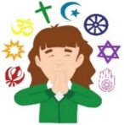

Communication and Language
- Word Warrior activities
- Using language to retell experiences
- Learning new vocabulary linked to
Transport, travel and other countries


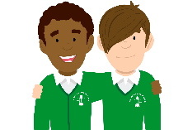

Expressive Arts and Design
- Home corner role play
- Building junk model vehicles
- Painting representations of different
environments
- Singing and creating songs from
around the world
- Exploring instruments from other countries

Spark day
- Trip to the Birmingham Sealife Centre to learn all about the different kinds of animal habitats around the world.

Physical Development
- Big moves
- Letter formation through phonics
lessons
- Using bikes and scooters
- Dough disco fine motor
activities
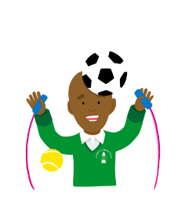
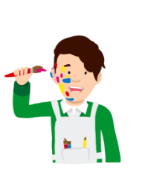
Book List
Monkey Puzzle The Hundred Decker Bus
The Ugly 5 Meerkat Mail
Pole Apart

