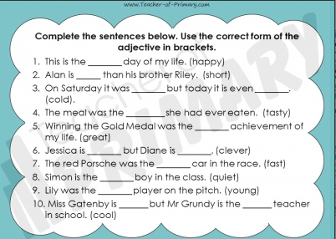
Comparative and superlative adjectives
Write out each sentence and include the correct adjective, comparative or superlative on each line.
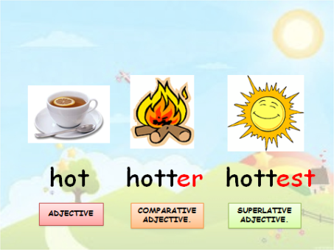
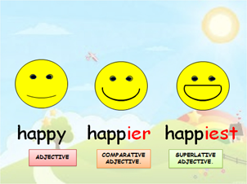
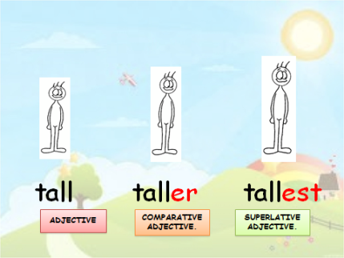
Yesterday, we looked at the rule if the adjective ends in a y and if there is only one consonant after the short vowel. There is one more rule to look at. If an adjective ends in an `e`, remove the `e` before adding `er` or `est` E.g. late - lat+er = later

With good and bad – we wouldn’t say gooder or goodest or badder and baddest
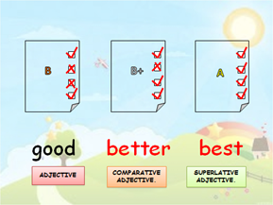
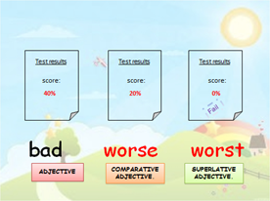
Now think about your healthy snack that you designed yesterday

Write down some adjectives to describe it
E.g. nice, tasty, healthy,

Now turn them into comparative adjectives by adding `er` suffix.
E.g. nicer, tastier and healthier

Finally turn them into superlative adjectives – as you want to show that your snack bar is the best out of all the other snack bars on the market.
E.g. nicest, tastiest and healthiest.

Next, for your English lesson, watch the Oak academy lesson and you will be using some of these words to create your own advert. Link is on the website.
Answers – Task 1
