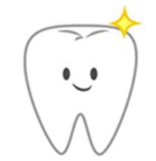
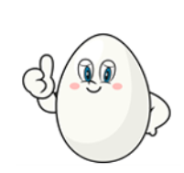
Meerkats and Penguins – Science experiment
Tuesday 23rd February
We have hard-boiled 6 eggs to represent teeth, as they also have 3 layers – the shell represents the enamel, the white represents the dentine and the yolk represents the pulp.
We have put each egg into a different drink. Next week we will take out the eggs and have a look at them. We will brush their shells and see if the eggs/teeth have been damaged in any way by each drink.

Your task is to make a prediction. What do you think will happen to each egg/tooth?

Drink | Prediction
Water
Coffee
Orange Juice
Milk
Coke
Coke Zero

