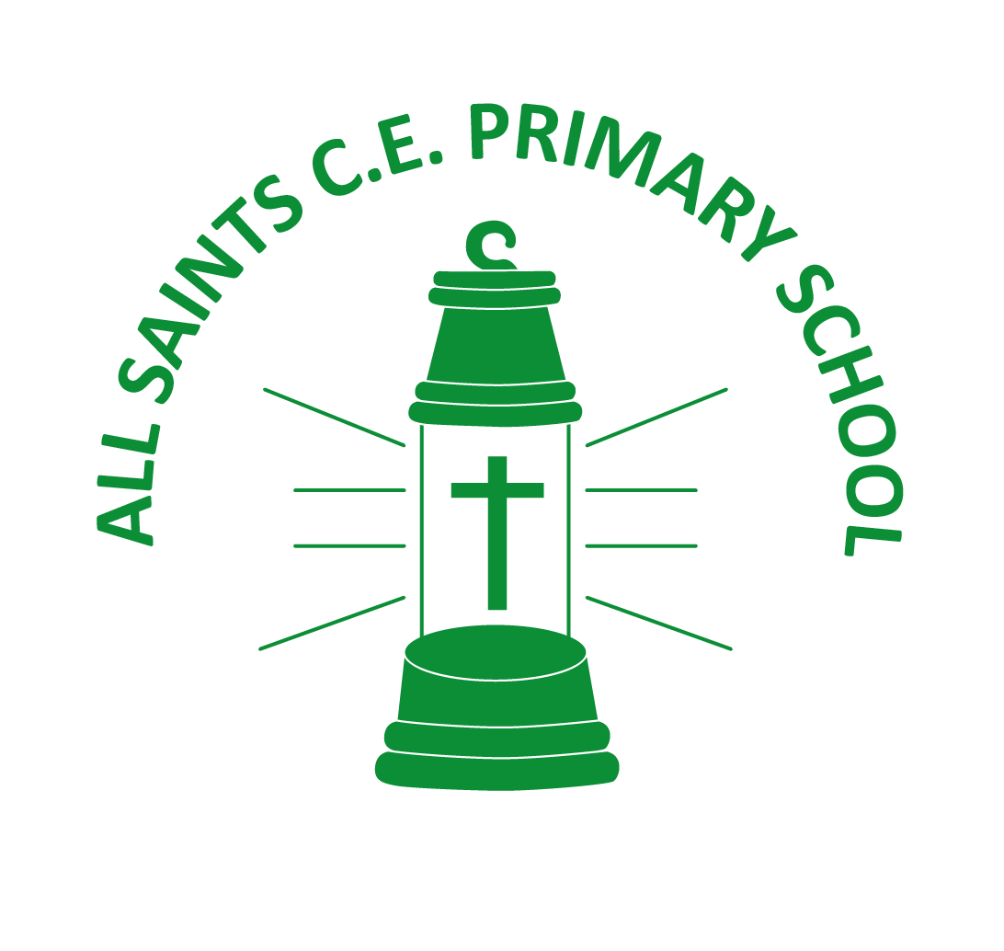

All Saints Primary School
Skills Curriculum Overview 2023-24

 | Autumn 1 | Autumn 2 | Spring 1 | Spring 2 | Summer 1 | Summer 2
Theme | Seconds from disaster | Nose in a book | Step back in time | We are scientists | Don’t forget your passport for… | Local Study - Coalville
Main Focus | Science/computing | English | History | Science | Geography | History/Geography
EYFS | Child focussed learning led by children’s interests
Year 1/2 | Everybody walk the dinosaur | London’s Calling | Remember me | Lion sleeps tonight | Lost in the woods | Hometown Glory
Year 3/4 | 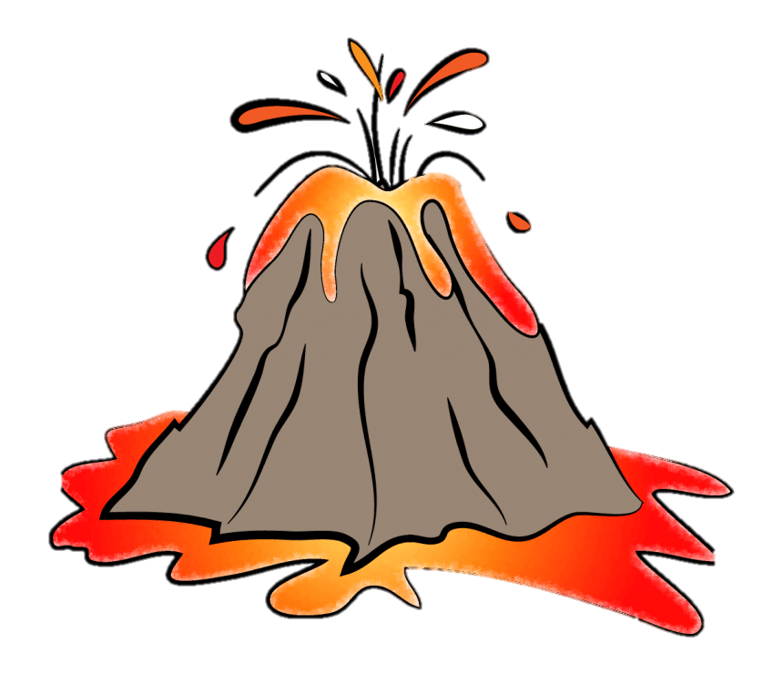  Let’s get ready to rumble | 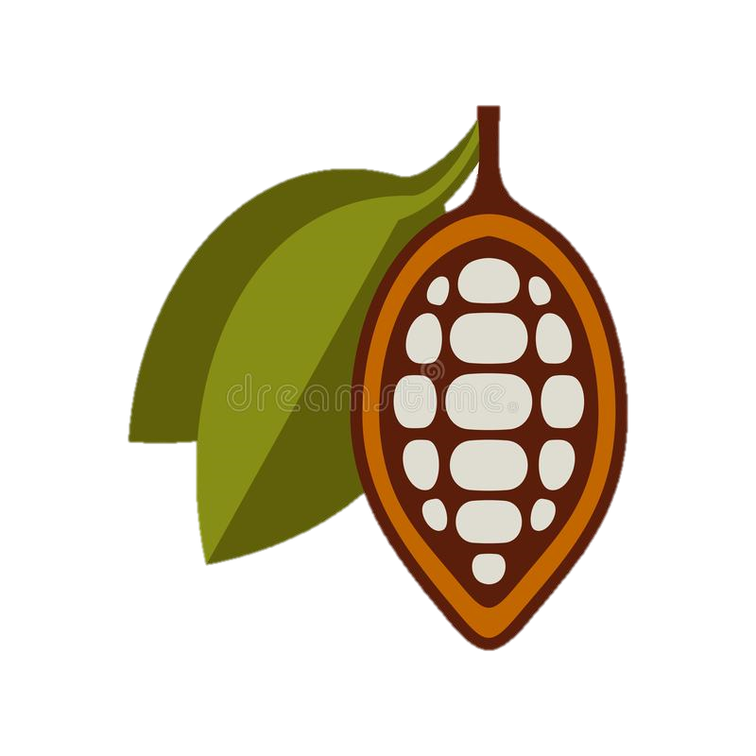  Choco-choco-late | Pompeii | Viking Rock | 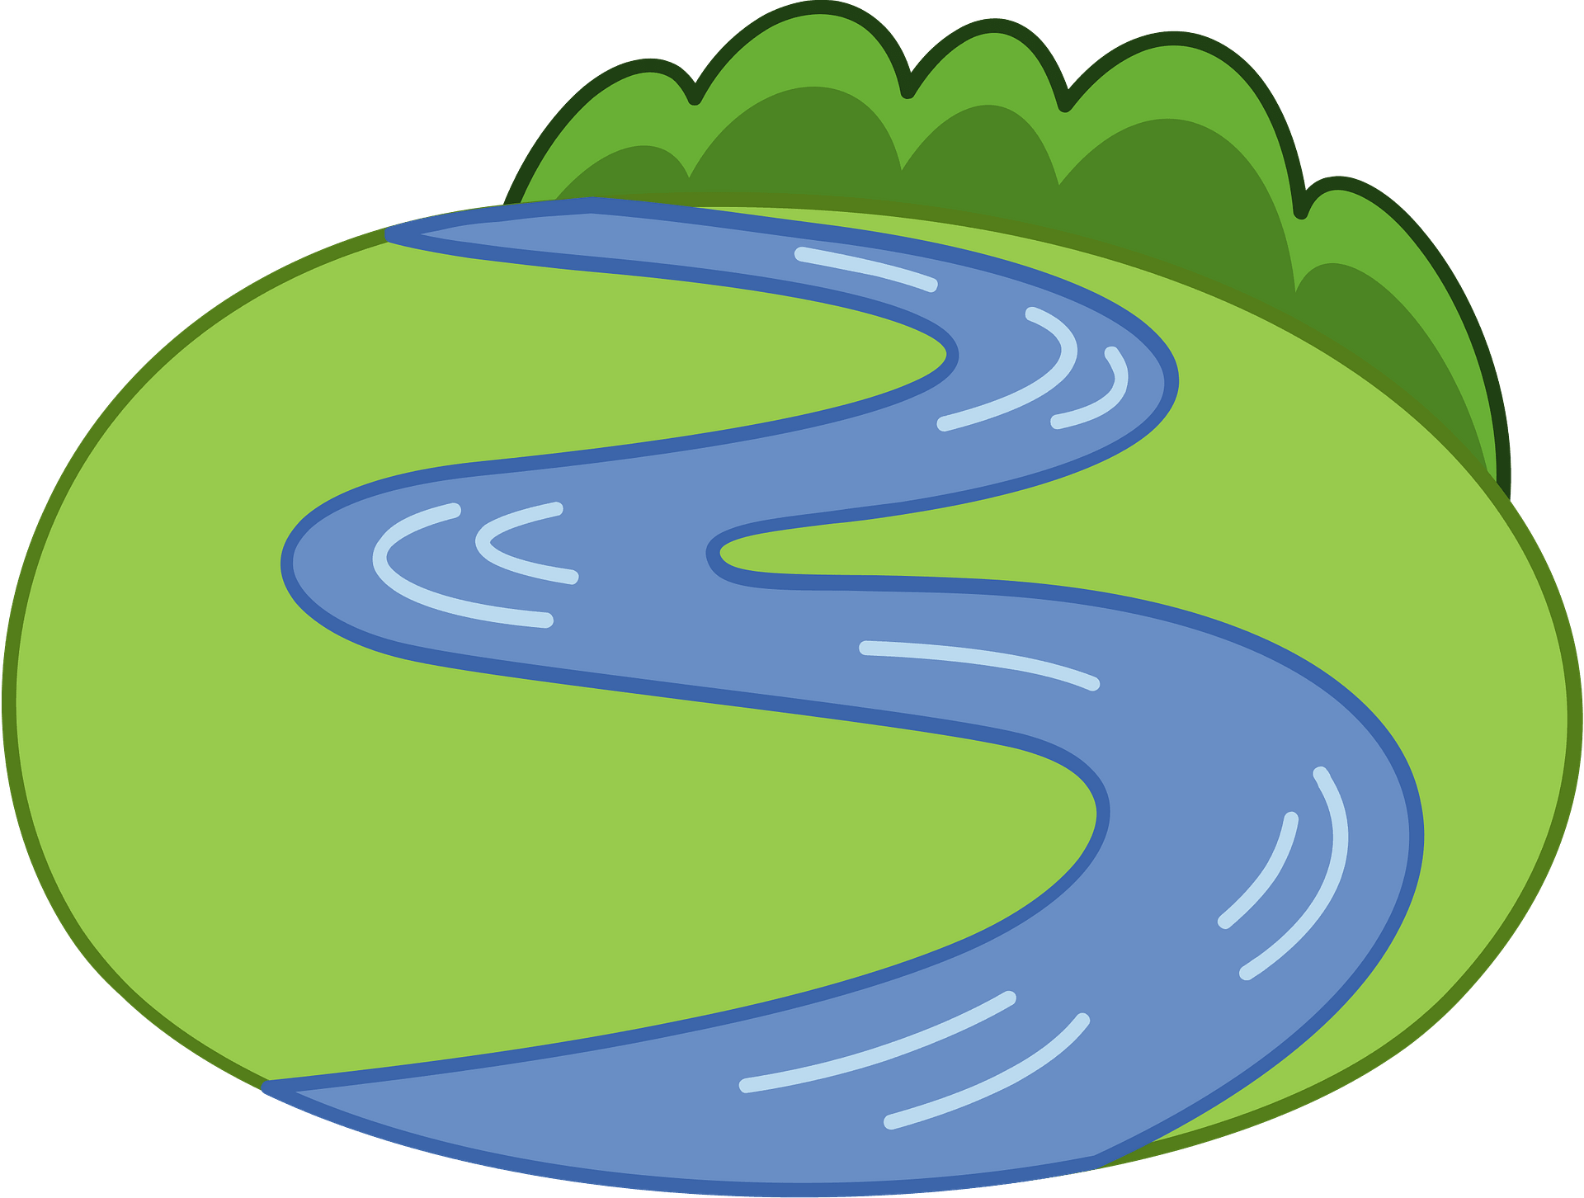  Just around the riverbend | Hometown Glory
Year 5/6 | Space Oddity | Roar | Greensleeves | Beat again | La Bamba | Hometown Glory

All Saints Primary School
Skills Curriculum Overview 2022-2023

 | Autumn 1 | Autumn 2 | Spring 1 | Spring 2 | Summer 1 | Summer 2
Theme | Adventure Time | Step back in time | Nose in a book | We are scientists | Don’t forget your passport for… | Local Study - Coalville
Main Focus | Science/computing | History | English | Science | Geography | History/Geography
EYFS | Child focussed learning led by children’s interests
Year 1/2 | Fly me to the moon | King of my castle | He’s a Pirate | Summer Holiday | Mas que nada | Hometown Glory
Year 3/4 | Eye of the tiger | 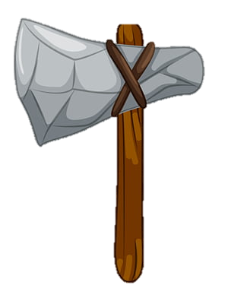  We will rock you | Go the distance | 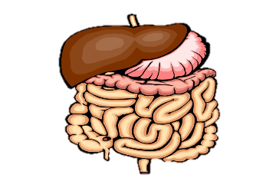  I’m only human | Born in the USA | Hometown Glory
Year 5/6 | Life is a Rollercoaster | We’ll meet again | Ice, Ice Baby | Born this way | Walk like an Egyptian | Hometown Glory
.

