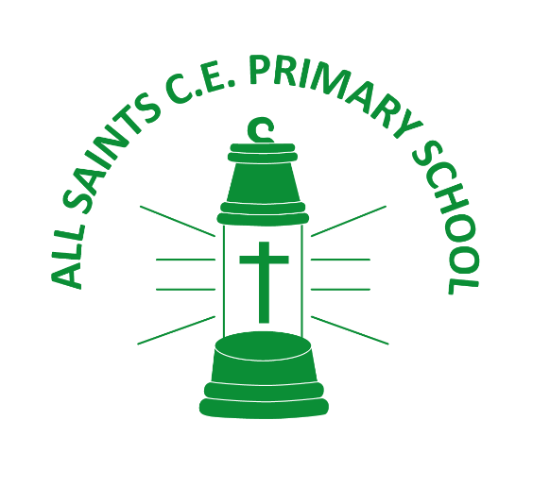

ALL SAINTS CE PRIMARY SCHOOL
HEAD, HAND AND HEART CURRICULUM DESIGN

 | Head  This is the KNOWLEDGE that the children need to acquire during the topic; key dates, events, people, facts and concepts are learned thoroughly. The children need to build up a strong KNOWLEDGE of the topic so that they can make predictions, conclusions and link their KNOWLEDGE to future learning opportunities. | Journeys of Discovery Curriculum  This is the CURRICULUM that children will experience at All Saints. Through inventive, creative and inspirational teaching. We want every child to develop an understanding of the big ideas which shape the world through the subject curricula.  Each subject domain has a carefully planned out and structured method of ensuring children develop the knowledge they need to understand the world. Ours is a developmental, thematic CURRICULUM that provides every child with the opportunity to  LET THEIR LIGHT SHINE!
Hand
This is the SKILLS that the children need to acquire during the topic. Craftsmanship and creativity are SKILLS that we value at All Saints. What ways can they ‘let their light shine’ using art, design, music, drama and/or computing SKILLS? Teacher must teach SKILLS to allow the children the chance to showcase their ‘Journey of Discovery’ using their new found SKILLS.
Heart
This is the VALUES that the children need to display during the topic. What ways can they ‘let theirs and others’ light shine?’ What opportunities do the children have to display our Christian VALUES? Our Collective Worship and Religious Education teaching ensures that children consider how religious teachings and faiths guide our VALUES and help us to become: kind, generous, wise, courageous, forgiving and self-controlled individuals.

